Repeating Gradient
Send Feedback

Given the below CSS code, when applied to an empty div will look like -
div {
height: 150px;
width: 300px;
background-image: repeating-linear-gradient(45deg, #9e6df9, #f77656 25%, #5ffc87 50%);
}

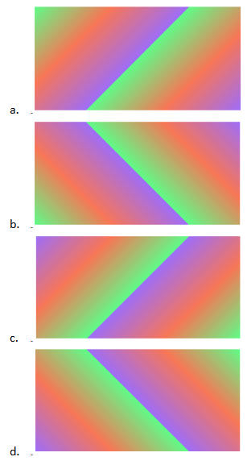

Ans: d

